Central Auckland Specialist School
Tāmaki Makaurau Te Kura Motuhake

_{Charter}
2018
Ko te ahurei o te tamatai arahia ō tātou mahi
Let the uniqueness of the child guide our work
To meet the expectations stated in our values we have specified practices we believe enable us to achieve these values.

The values are the core beliefs on which our school is founded. They are the moral principles we consider as most important.
The vision is what we hope to achieve for our learners. It is the ideals we hold as being at the heart of our school’s values.

Description of the school Community

Central Auckland Specialist School is a state co-educational school situated in central Auckland which is newly established after the merger of Sunnydene and Carlson Special Schools. CASS provides quality education for with intellectual disabilities, many of whom may also have physical, sensory or behaviour disabilities. Our students are aged between 5 – 21 years and are funded through the Ongoing Resourcing Scheme Funding (ORS)
Our school has 22 classrooms are located across Central Auckland and include our base school site, satellite classes and the St Andrews road campus (formally Carlson). Classes are organised to ensure students of a similar age and who benefit from similar approaches to teaching and learning are grouped together. The school also offers a comprehensive Specialist Outreach Service, supporting ORS funded students in their mainstream schools.

CASS employs are large number of Teacher aides and therapists to support the learning of our students. The organisation structures of the school are designed to meet the challenges of a diverse students population, large number of staff and geographical locations of our classes.

Treaty of Waitangi
We value the Treaty of Waitangi and strive to meet the principles, participation and partnership inherent in this founding document. Therefore, in all matters the school should reflect the bicultural nature of Aotearoa . In all our interactions we recognise the importance of tika ( honesty ), pono ( trust), aroha ( compassion), Whanaugatanga ( relationship), and wairua ( spirituality)

Achievement Statement
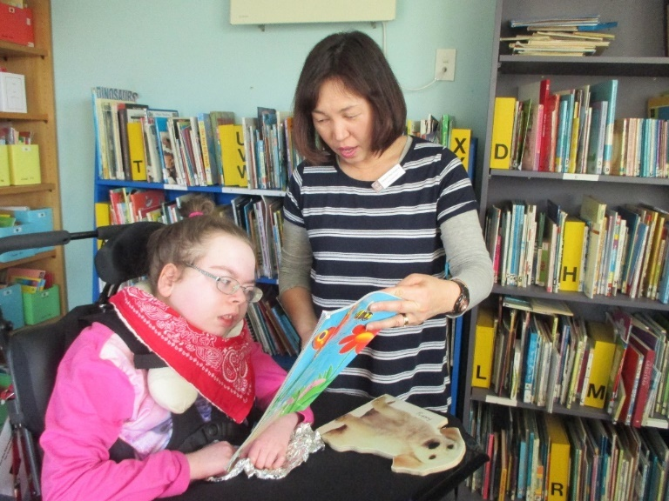
At Central Auckland Specialist School, progress and achievement is highly individualised and considers students learning in a holistic way. We place a high value on the partnership and collaboration we have with families and whanau throughout a students’s learning journey. Through the implementation of IEPs and the New Zealand Curriculum, learning intentions are developed which articulate students’ personalised learning pathways. We recognise that our students do not always follow a linear learning process and that learning steps may sometimes be small, can take time and achievement may not always occur in the way we predicted. Assessment and reporting systems attempt to capture this and focus on what students’ can do and work to build on the skills and abilities that they bring to their learning. To support students’ achievement, staff maintain high expectations about what students are able to achieve and students are celebrated as learners.

Strategic Goals 2018 - 2020

- Vision – To collectively form a living vision that embraces a culture of shared values and beliefs of all learners within the community of Central Auckland Specialist School
Objectives | Related Development Plans
- Staff and the community will continue to evolve our shared vision and mission statements  - Community consultation will be conducted  - Family / whanau will be engaged in creating our welcoming, inclusive school environment  - Procedures and operational systems will be developed to support the enactment of the schools vision  - Procedures will be cohesive, published and embedded across the newly merged school  - Systems will be reviewed and aligned  - Property and school environments will be developed and sustained to reflect our vision for learning at CASS | Parent / Whanau Engagement  Digital Technologies and e-learning  Outreach  Therapy Provision  Positive Behaviour
- Pedagogy – To establish a pedagogical vision that reflects and monitors the differentiated learning needs of all students
Objectives | Related Development Plans
- Students will continue to progress and achieve in their learning  - Progress and achievement is analysed and reported  - Teaching and learning programmes are informed by best practice and differentiated for learners  - Professional Learning and Development is provided to staff to support learning programmes and enable teacher effectiveness  - CASS will develop a local curriculum framework which links the New Zealand Curriculum ( including key competencies ) and IEPs  - Every student will have an individualised learning plan which identifies and tracks progress  - Our curriculum will reflect an ongoing focus on e-learning, communication , literacy cultural responsiveness and the arts | Individual Education plans  Engagement for Learning  The Arts  Inquiry Learning  Numeracy  Literacy  Communication  Transition  Assessment and Reporting  Curriculum  Health and PE  Intensive Interaction  Recreation
- Leadership – To establish a strong and dynamic leadership team to lead CASS. To build capacity and capability of leaders at CASS
Objectives | Related Development Plans
- Leaders have a high level of communication within and across teams  - Communication systems will be established  - Leaders will have a commitment to ongoing professional growth of themselves and others  - Exploring coaching and mentoring | Teacher Aide Development  Appraisal and Professional Development  Biculturalism

School Organisation

School Organisation 2018
Junior | Middle | Senior
Belinda Rowe | Helen Walker | Stephen Doel
Learning Leaders : Katie & Marissa |  | Learning Leaders: James and Susan
May Road 1 | Balmoral 1 | Onehunga 1
May Road 2 | Balmoral 2 | Onehunga 2
Dominion Road 1 | Waikowhai | Community 1
Dominion Road 2 | Carlson 6 | Community 2
Oranga 1 | Carlson 3 | Base 2
Oranga 2 |  | Base 4
Carlson 7 |  | Style 1
Carlson 4 |  | Style 2
 |  | Carlson 5

Delegations
Trudi Brocas | Belinda Rowe | Helen Walker | Stephen Doel
Principal | Deputy Principal | Associate Principal | Associate Principal
Appraisals  Curriculum  Self Reviews  Property  Host school Liaison  Personnel  Policies and procedures  School communications  ICT | Enrolment Coordinator  Assessment for Learning  Health and safety  Pastoral care / attendance officer  Visitor and external providers coordinator | Teacher Aide Manager  Outreach Team  EOTC coordinator  Transport coordinator  Sunnydene site manager  RDA Co-ordinator  Professional Development Co-ordinator | Relievers Coordinator  Arts Team  Health and PE Co-ordinator  CRT co-ordinator  Transition Co-ordinator  Maori and Pasifika  Carlson Site Manager  Whole School Events  Arts team leader
Jay Bhana and Melinda Allen |  | Other Unit Holders
Therapy – Team Leaders |  | Jessica Robert – Engagement for Learning
Health Co-ordination
Nursing students co-ordinator

Learning Leaders
Katie Dooley – Junior Team + Intensive Interaction
Marisa Lobo – Junior Team + Inquiry Learning
James Ryan – Senior Team + Behaviour
Susan Hugo – Senior Team + Recreation

Meetings
Meeting | Day | Frequency | Time
Whole Staff | Tuesday | Fortnight ( even weeks) | 3.20-4.20
Team Meeting | Tuesday | Fortnight ( Odd Weeks) | 3.20-4.20
Senior Leadership Meeting | Monday | Weekly | 9.00-11am
Therapy Team Meeting | Tuesday | Fortnightly | 3.20-4.20
Therapy Coordination Meeting | Thursday | Fortnightly | 2.30-3.30
Class Meetings | As needed
Board of Trustees | Thursdays | Wk 3 & Wk 8 | 6.30-8pm
Outreach Team | Tuesday | Fortnightly | 3.20-4.20

Board of Trustees
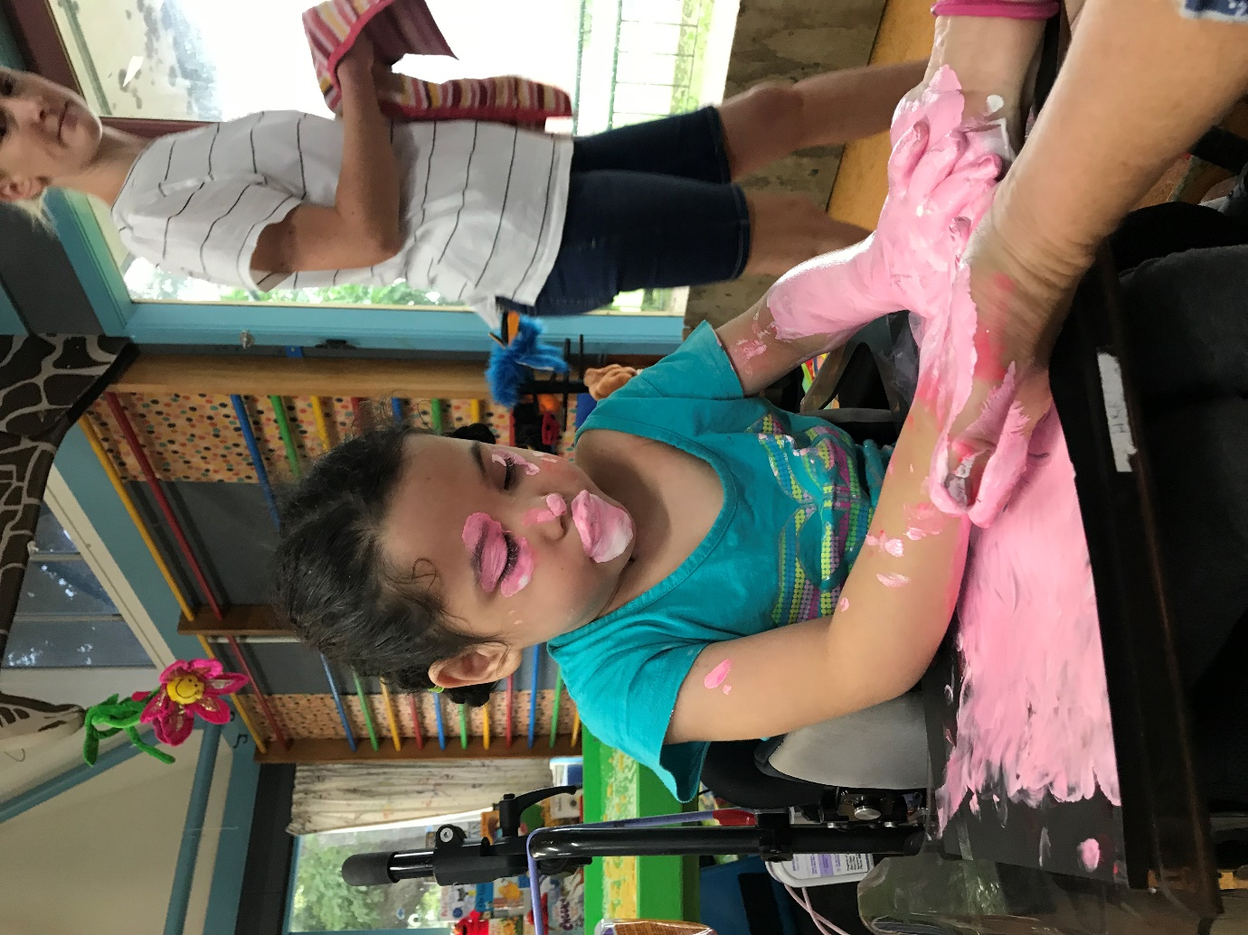

 | 2018 | 2019 | 2020
Curriculum |  | Curriculum Delivery
Personnel | Personnel Policy | Appointments Policy | Disciplinary Process in relation to the principal
Finance and Property | Principals Professional Expenses | Financial Planning  Financial Condition | Asset Protection  Trustee remuneration and expense
Health and Safety |  | Health and Safety | Child protection
Governance | Board roles and responsibilities  Responsibilities of the principal  Reporting to the board  Principals performance management  Committee | Trustees code of behaviour  Conflict of interest  Relationship between the board and the chair  Board Induction  Meeting process + Meeting Procedure  Concerns and complaints | Chairs role description  Student/Staff trustee role description  Relationship between the chair in the principal  Board Review
Other |  | Protection of Sharing of intellectual property | Legal responsibilities

Policy Review Timeline

Board of Trustees Work plan
2018  Review | Area for Review | FEB | MAR | MAY | JUNE | JULY | AUG | SEP | OCT | NOV | DEC
STRATEGIC REVIEW | CHARTER | Confirm Charter- approve and send to MOE |  |  |  |  |  |  | Review strategic plan | Approve review plan for 2018  Analysis of Variance | Annual Plan draft
 | STRATEGIC AIMS |  | 1 | 2 | 3 |  | 1 | 2 | 3
REGULAR REVIEW | POLICY |  |  | Personnel | Principals Prof expenses | Board role and resp | Resp of the principal | Principals perf man | Committee
 | HR REPORTS |  |  | Outreach | Professional  Development |  |  |  |  | Principal P/formance Review Report
 | STUDENT PROGRESS AND ACHIEVEMENT | Student Achievement previous year
 | OTHER REPORTS | Behaviour-  Incident Data |  |  | Attendance | Transition | Num/Lit | Maori/Pas. | Health | MU Reports
 | BUDGET | Approved.  Fundraising Review | Monitor | Monitor | Monitor | Mid-year review | Monitor | Monitor | Monitor | Monitor | Draft for 2018.
BOARD PROCESS REQUIREMENTS |  | Appoint chair  Principal Perf Goals | Accounts to auditor | Annual Report Approved and sent to MOE |  | Health and Safety Checklist | Health Curriculum Consultation | Formulate Parent Survey | Board Review | Survey results  Work Plan 2018 | Confirm meeting dates 2018

Target Action plan &
Annual Development Plans
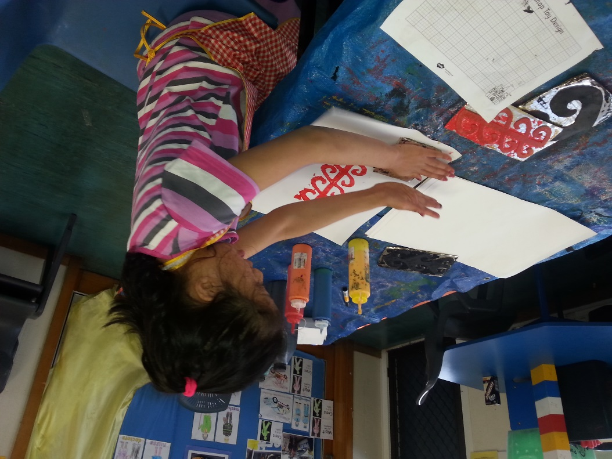

Target Action Plan – Numeracy 2018
 |  | When | Actions |  | Responsible
Background: Observations in 2017 of StAR site (ex Carlson) of maths programmes focused on planning, programmes and resources to support the effective and individualised teaching of mathematics in the school. A successful MOE application for PLD from the university of Auckland was made and when Carlson and Sunnydene schools merged this year, data for all students was analysed together. Teachers and Leaders have identified that a common framework,collaborative planning and implementation and evaluation across classes as to the positive impact on mathematics teaching and learning in the new school. |  | Term 1 | - Delivery plan of service completed with University of Auckland  - Introduce Adult Curriculum to Senior Syndicate  - Teachers share good practice with others  - Formulate a maths working group  - Look at data and analyse |  | Stephen and Uni of AKL.  Stephen and  Senior Syndicate  Stephen  Senior Syndicate and Maths Team
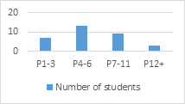  Target: All target students will make measurable progress using B-squared, PIVATS and QUEST assessments. The target group is 32 Senior Students across the newly merged school aged between 18-21 years of age. Current 2016-2017 achievement levels show that these students stayed at the same level or showed a small level of progression compared with other students in the school. Students have a range of special needs including cerebral palsy, PMLD, Down Syndrome, ASD and others, all with intellectual disabilities.  In this group  - 14 students made no gains in achievement from 2016-2017  - 18 students made gains of between .01 to 0.8 in P-levels. 2016-2017 |  | Term 2 | - Begin collection of observational data  - Begin development of CASS Math framework  - Begin PLD meetings/sessions with Uni of AKL.  - Explore relevant resources, trial and review effectiveness  - Other class and school visits to observe Maths practice |  | Stephen & UoA  Maths team  UoA / Stephen  Maths Team  Senior Class Teachers
 |  | Term 3 | - Review use of Adult Curriculum  - Explore relevant resources, trial and review effectiveness |  | Maths Team / SS  Maths Team
 |  | Term 4 | - Review data collection and analyse  - Generate next steps for 2019 from findings.  - Generate and build a resource bank for mathematics, digital and hard objects.  - Celebrate and share learning. |  | Maths Team  Maths Team  Maths Team  SS & Maths Team
Teacher Knowledge  - PLD and service delivery from Uni of AKL.  - Sharing of knowledge and planning through meetings.  - Develop working group for Maths  - Gauge teachers confidence and maths attitude post PLD  - Visit other special schools and observe maths programmes | Resources  - Explore effective math apps  - Develop a resource bank of math apps.  - Work with Uni of AKL in developing Augmented Reality software for PMLD students.  - Develop real contexts for number and | Curriculum  - Introduce and maintain Adult Curriculum  - Set up real life contexts for generalised maths learning to be practiced and embedded.  - Focus on engaging maths activities over a range of levels.  - Link STEM activities to capture interest and engagement. |  | Assessment and Reporting  - Explore appropriate assessments and reporting formats for a range of levels.  - Develop clear and concise communications in our reporting to families linked to learning.  - Create stronger links between Assessments and planning for teaching and learning.

